 | 5 | 3 | 1
Content | Content is accurate and all required information is presented in a logical order. | Content is accurate but some required information is missing and/or not presented in a logical order. | Content is inaccurate. Information is not presented in a logical order, making it difficult to follow.
Pictures, Clip Art Background | Images are appropriate.  Layout is pleasing to the eye. | Most images are appropriate | No images
Mechanics | No spelling errors. No grammar errors. | Some spelling errors. Some grammar errors. | Many spelling and or grammar errors.
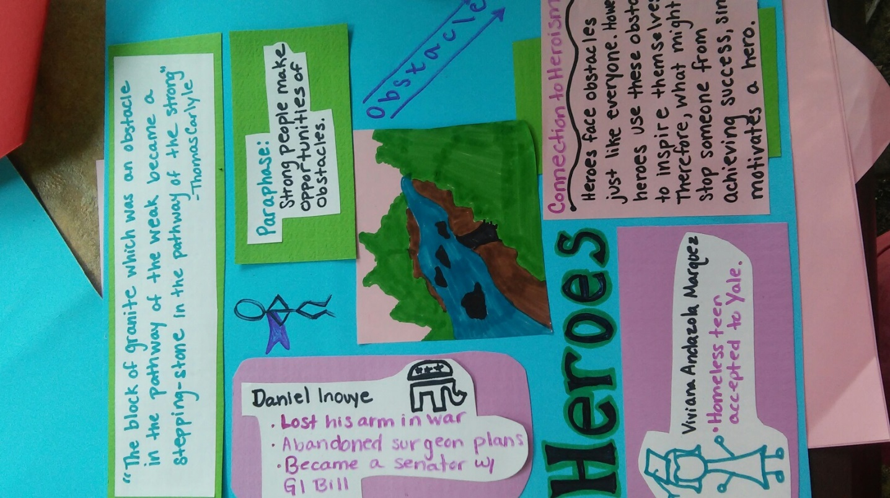

Quotation Poster Assignment
Select your quotation from page 6
Your poster should include:
- The word heroes
- The quotation and speaker
- A paraphrase
- Two examples from real life; you may want to look to the news
- A category of obstacle, difficult task, and/or opportunity
- A visual representation
Tips:
Try to fill the space
Use a pop of color by mounting your thoughts on colored paper
Can’t draw? Look up how to draw a ____ on the internet

Rubric

